**This chart will show the count of shows in each genre to identify the most popular genres on Netflix**

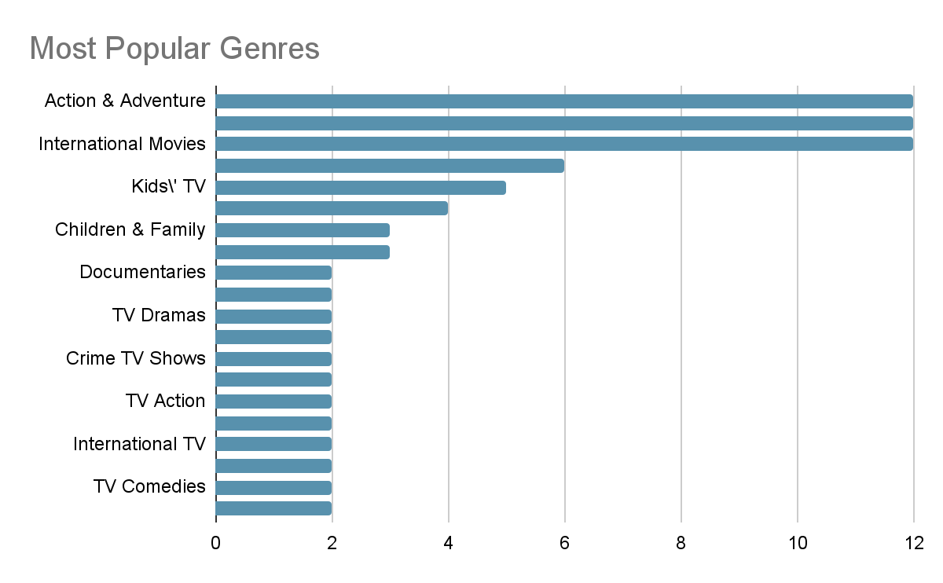

**I.e Bar chart**

| Genre | Number of shows |
| --- | --- |
| Action & Adventure | 12 |
| Anime Features | 12 |
| International Movies | 12 |
| Children & Family Movies | 6 |
| Kids\' TV | 5 |
| Reality TV | 4 |
| Children & Family Movies | 3 |
| Comedies | 3 |
| Documentaries | 2 |
| International TV Shows | 2 |
| TV Dramas | 2 |
| TV Mysteries | 2 |
| Crime TV Shows | 2 |
| International TV Shows | 2 |
| TV Action | 2 |
| Adventure | 2 |
| International TV Shows | 2 |
| Romantic TV Shows | 2 |
| TV Comedies | 2 |
| TV Dramas | 2 |

**This chart will display the proportion of shows produced by the top 10 countries.**

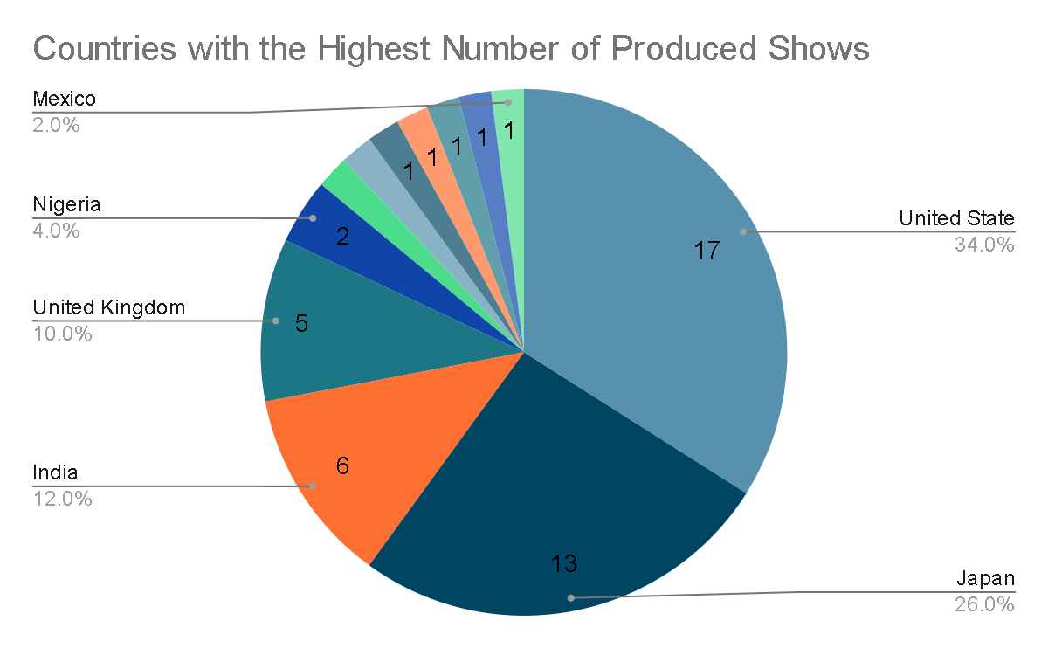

**I.e Pie chart.**

| Country | Number of shows |
| --- | --- |
| United State | 17 |
| Japan | 13 |
| India | 6 |
| United Kingdom | 5 |
| Nigeria | 2 |
| South Africa | 1 |
| Ghana | 1 |
| Burkina Faso | 1 |
| Germany | 1 |
| Ethiopia | 1 |
| Czech Republic | 1 |
| Mexico | 1 |

**This chart will show the number of shows released each year to observe trends over time.**

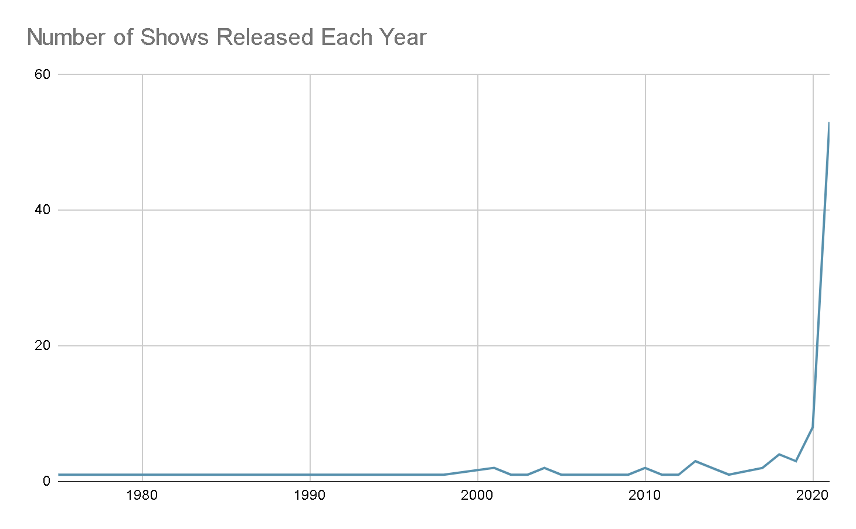

**I.e Line Chart**

| Release Year | Number of shows |
| --- | --- |
| 1975 | 1 |
| 1978 | 1 |
| 1983 | 1 |
| 1987 | 1 |
| 1993 | 1 |
| *1994* | 1 |
| 1996 | 1 |
| 1997 | 1 |
| 1998 | 1 |
| 2001 | 2 |
| 2002 | 1 |
| 2003 | 1 |
| 2004 | 2 |
| 2005 | 1 |
| 2006 | 1 |
| 2007 | 1 |
| 2008 | 1 |
| 2009 | 1 |
| 2010 | 2 |
| 2011 | 1 |
| 2012 | 1 |
| 2013 | 3 |
| 2014 | 2 |
| 2015 | 1 |
| 2017 | 2 |
| 2018 | 4 |
| 2019 | 3 |
| 2020 | 8 |
| 2021 | 53 |